Alexander Flood
23rd, June 2024
CS-255 System Analysis and Design

Slide 1

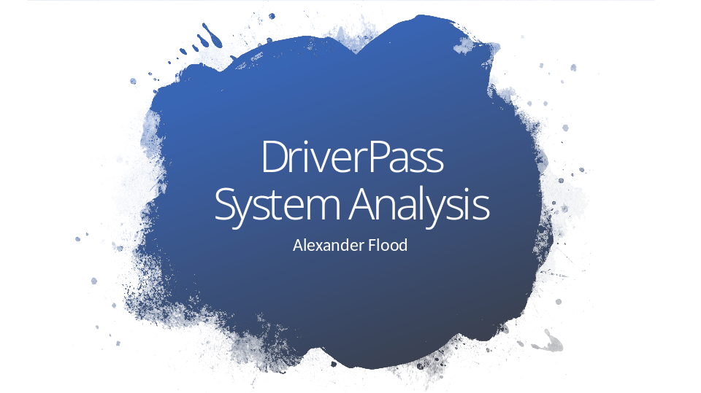

[No speaker notes required for this slide.]

Slide 2

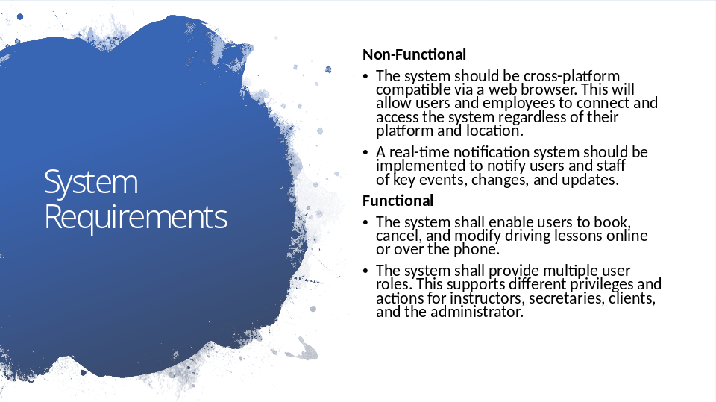

For the DriverPass system, I have identified key functional and non-functional requirements to ensure efficient operation and user satisfaction. The functional requirements include enabling users to book, cancel, and modify driving lessons online or over the phone, providing flexibility and convenience in managing their reservations. Additionally, the system provides multiple user roles, ensuring that instructors, secretaries, clients, and administrators can have access to functionality that fits their needs. This separates our clients from our staff at the system level and enhances security by keeping users from accessing administrative functions.

On the non-functional side, the system must be cross-platform compatible, allowing access from various devices such as PCs, tablets, and smartphones. This ensures that users and employees can connect to the system regardless of their location and device. The system also implements a real-time notification system that is crucial for keeping users and staff informed about key events, changes, and updates. These real-time notifications will enhance communication and help keep both staff and users engaged.

Together, these requirements provide a foundation to ensure DriverPass provides a comprehensive and user-friendly platform, helping users improve their driving skills and knowledge to prepare for their DMV assessment.

Slide 3

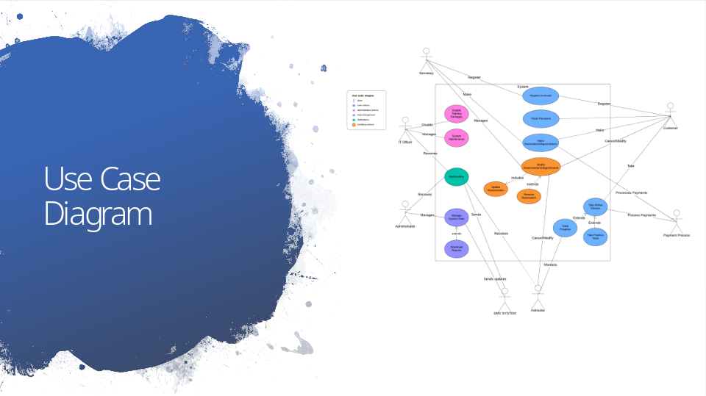

The system design for DriverPass includes several types of users with specific roles: customers, secretaries, IT officers, administrators, instructors, the DMV system, and payment processor. Customers use the system to register accounts, reset passwords, book, cancel, and modify driving lessons, take online classes, and practice tests, and make payments. Secretaries can assist customers with account creation and reservations. IT Officers maintain the system and manage training packages, while administrators oversee system data and generate reports. Instructors monitor and track customer progress, manage their reservations, and assist with online classes and practice tests.

This comprehensive design provides users and staff with the functionality they need while maintaining security and remaining user friendly. By allowing customers to manage their lessons and access learning materials, secretaries provide support, and IT Officers provide system maintenance and keep packages up to date, we enhance the overall user experience. Administrators manage data and reporting, while instructors guide customer progress and the payment process handles secure transactions. This comprehensive approach meets DriverPass needs, providing a user-friendly platform to support driving skill improvement and DMV assessment preparation.

Slide 4

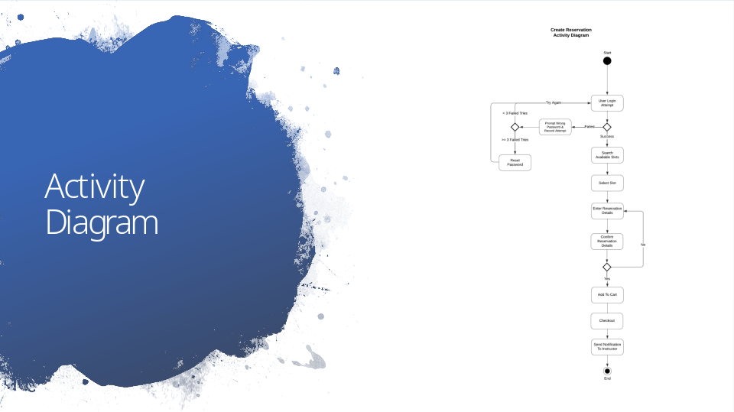

This diagram visualizes the process for a customer creating a reservation for a driving lesson. The process begins with the user attempting to log in. If the login attempt fails, the system prompts the user with an incorrect password message and records the attempt. If there are fewer than three failed attempts, the user can try again. If there are three or more failed attempts, the user is directed to reset their password. Upon a successful login, the user can search for available time slots, select a preferred slot, and enter reservation details. After confirming the reservation details, the user adds the reservation to their cart, and proceeds to checkout. Finally, a notification is sent to the instructor to confirm the booking.

This design ensures a seamless and secure experience for managing reservations. It enhances security by setting a limit on failed login attempts and requiring a password reset after multiple failed attempts. This not only protects user accounts, but also protects the integrity of the system. By accommodating the need for a flexible booking system with added security measures, the process remains user-friendly while ensuring the safety of user data and system data.

Slide 5

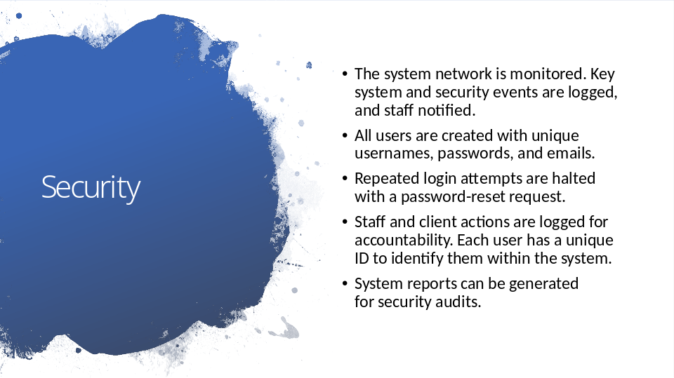

In designing the DriverPass system, security was a top priority to ensure the integrity and safety of user and system information. First, the system network is monitored, and any significant system event is recorded with staff being notified in real-time. This allows staff to respond to security events and system issues as they occur. All user accounts are created with unique usernames, passwords, and emails. This ensures no duplicate accounts are created and unique emails are used for each account.

To prevent unauthorized access, repeated login attempts for user accounts are monitored with excessive attempts blocked. This prevents hackers from gaining access through compromised accounts which also protects system data and user trust. Furthermore, staff and client actions are logged for accountability, with each user having a unique ID to identify them within the system. This ensures all activities can be traced back to individual users. Lastly, the system can generate reports for security audits, helping to identify any vulnerabilities or issues within the system.

Slide 6

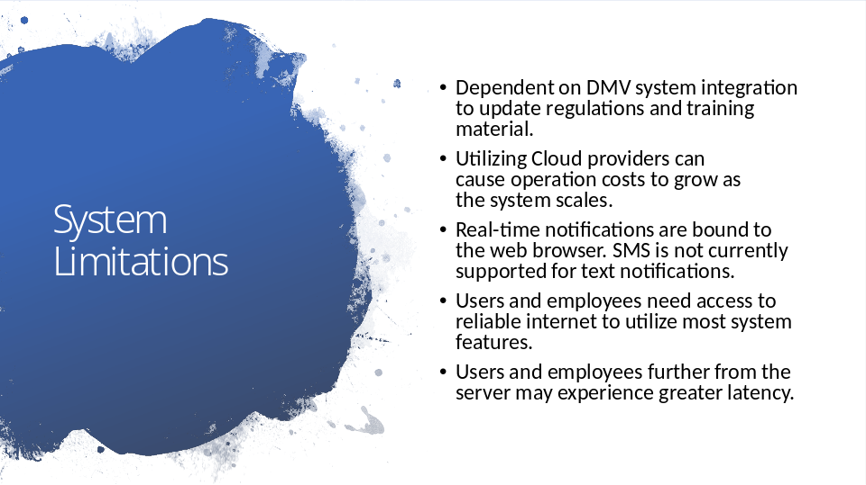

There are several limitations to the DriverPass system design to consider. First, the system relies heavily on integration with the DMV's system to ensure that regulations and training materials are kept up to date. This reliance means that any changes or delays from the DMV can impact our system's performance and accuracy. Additionally, while cloud providers offer scalability, it can also lead to increased operational costs as the system grows. Further plans could explore more cost-effective cloud solutions.

Another limitation is that real-time notifications are currently restricted to web browsers, with SMS notifications not yet supported. This means the user must be online to receive immediate updates. Additionally, a reliable internet connection is required for both users and employees to utilize most of the system’s features effectively. Users and employees who are located further away from the server or connected to a weak Wi-Fi signal might experience slower system performance, which could affect their overall experience. Exploring how we manage server locations and internet connections could help address these limitations.

